**LAB-3**

1. Count how many vowels are there in a string

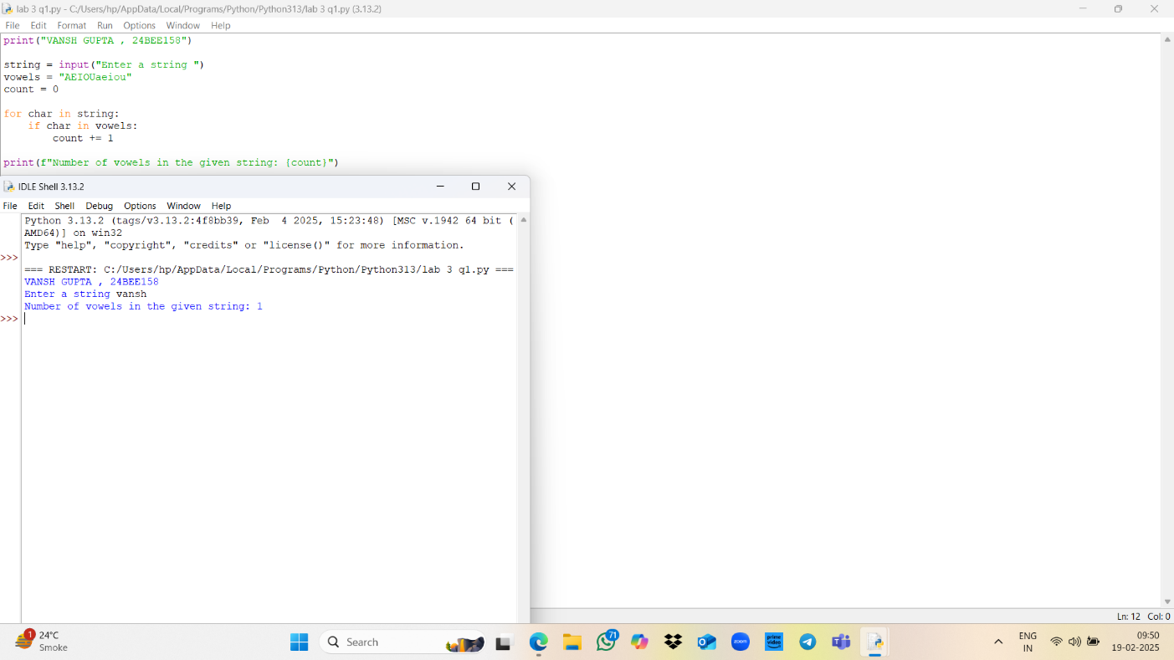

1. Convert all characters of a string into lower case, upper case, and toggle case (without built-in functions)

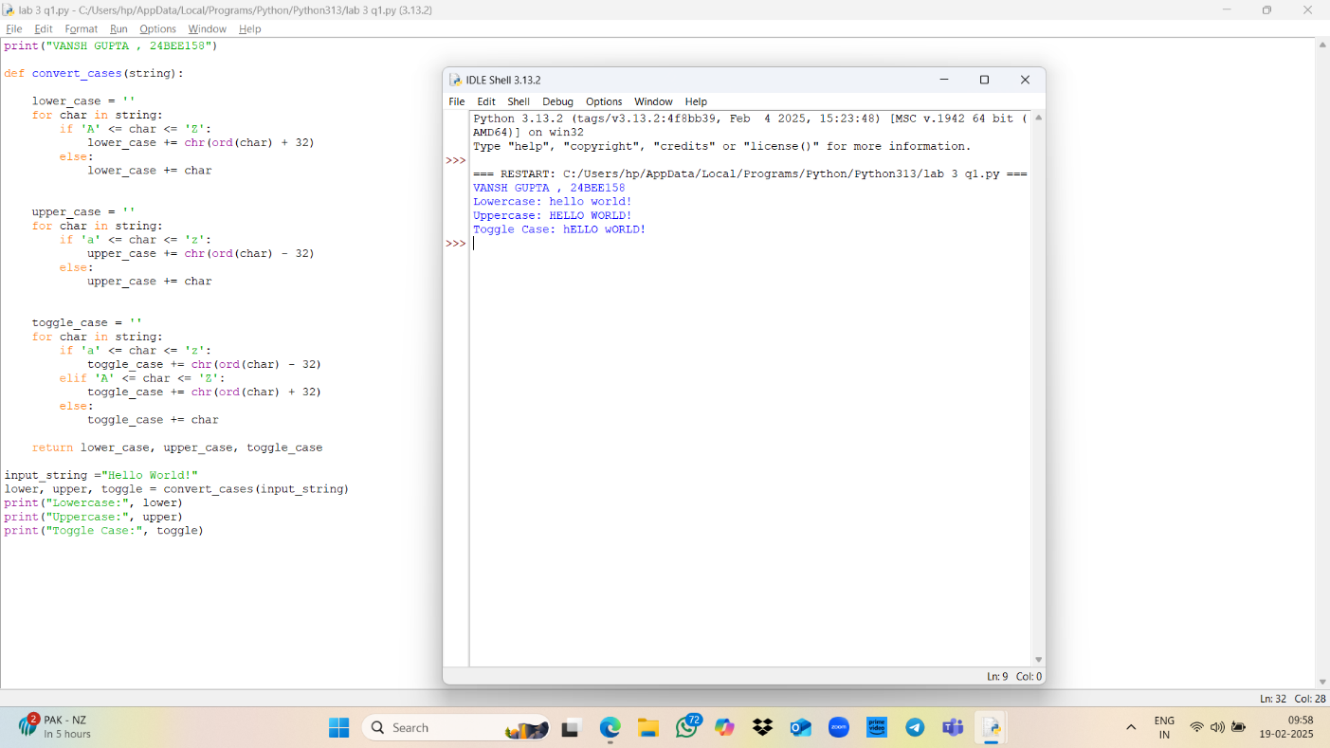

3)Check whether one string is present in another

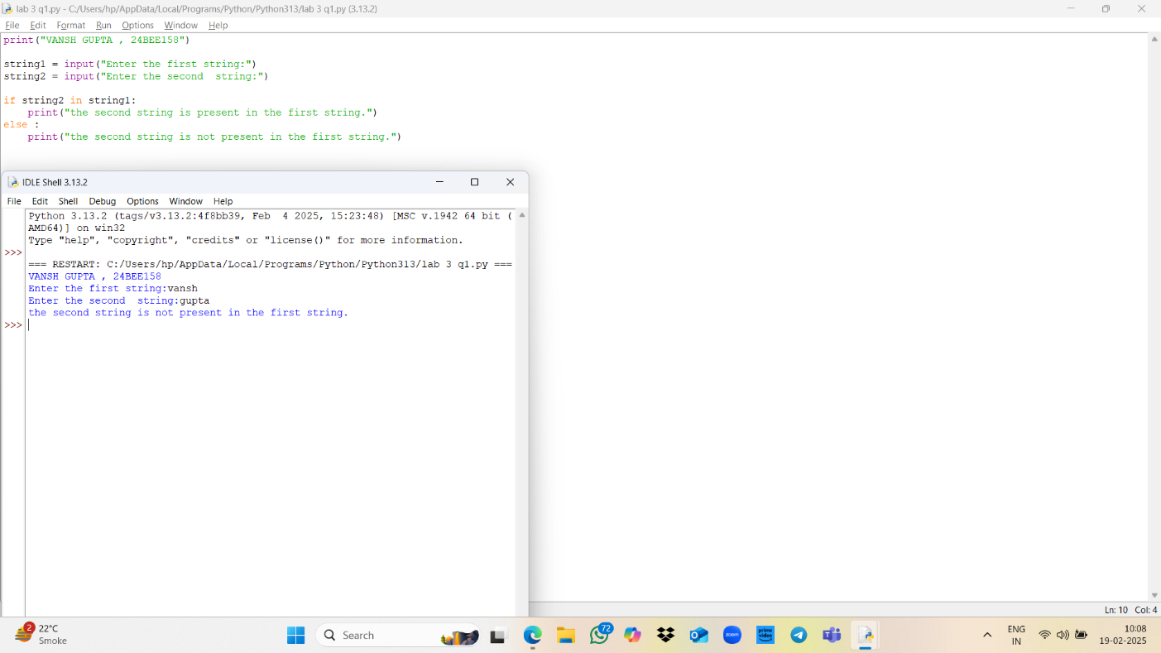

1. Remove one string from another string if present

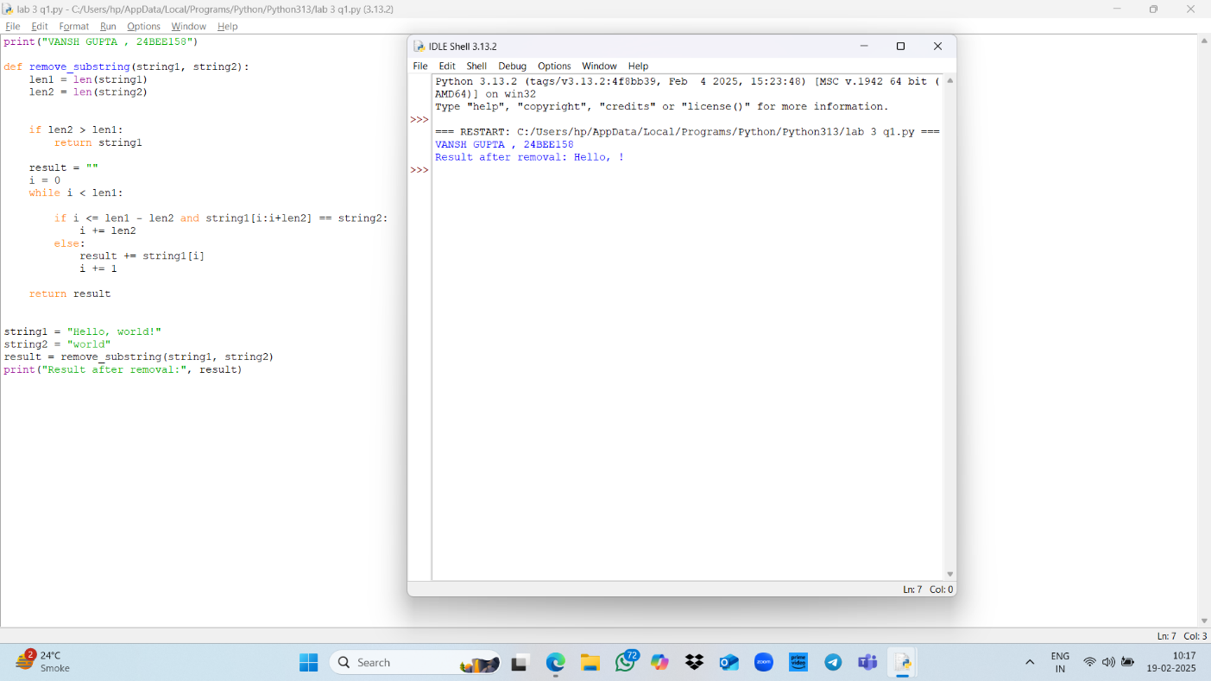

1. Write a program to count number of vowels, consonants and special characters in a string where string is input by user

